Mirror reflection

Harry the hedgehog looks at himself in a mirror.
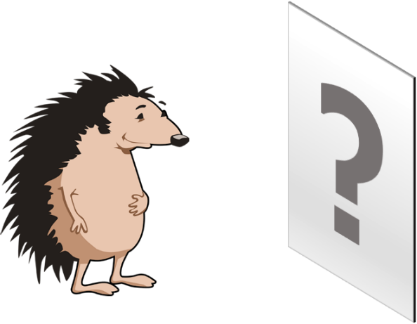

The mirror has a special name because it is flat.
It is called a plane mirror.

How can you describe Harry’s reflection?
For each statement, tick (✓) one column to show what you think.
 |  | I am sure this is right | I think this is right | I think this is wrong | I am sure this is wrong
A | Harry’s reflection is on the mirror
B | Harry’s reflection looks back to front
C | Harry’s reflection is the same size as Harry
D | Everyone looking at the mirror sees the same reflection that Harry sees

Physics > Big idea PSL: Sound, light and waves > Topic PSL3: Making images > Key concept PSL3.1: The ray model of light to explain images
Diagnostic question
Mirror reflection

Overview
Learning focus: | A plane mirror reflects light rays from each point of an object so they appear to come from distinct points behind the mirror and the reflection is seen as if it were behind the mirror.
Observable learning outcome: | Compare the reflection of an object in a plane mirror to how the object looks.  Describe where the reflection of an object appears to be in a plane mirror.
Question type: | Confidence grid
Key words: | Reflection, plane mirror

P | PRIOR UNDERSTANDING  This diagnostic question probes understanding of ideas that are usually taught at age 5-11, to aid transition from earlier stages of learning.

What does the research say?
Unlike pinholes, plane mirrors do not form (real) images that can be projected onto a screen. Notwithstanding, many students think that a mirror forms an image that can be viewed as if the mirror were a photograph (Ceuppens et al., 2018; Galili and Hazan, 2000). About a quarter of 13- to 15-year olds in a study by Fetherstonhaugh and Treagust (1990) thought that light stays on a mirror during reflection. Before teaching, Galili and Hazan (2000) found that about half of students thought that mirrors duplicate (reflect) objects by creating an image. This misunderstanding fell significantly after teaching, but over a quarter of students aged 14-16 persisted in thinking that the image travels to a mirror and bounces off it, and that if there were obstacles between the object and the mirror, the obstacles prevent the image from reaching the mirror. Other studies have shown it is common for students to think that a mirror inverses the image from right to left (Bendall, Goldberg and Galili, 1993; Galili, Goldberg and Bendall, 1991; Galili and Goldberg, 1993).
A challenge to understanding how an object is seen in a plane mirror is the fact that the observer is an inherent part of the optical system (Galili and Hazan, 2000; Andreou and Raftopoulos, 2011). It is perhaps helpful to discuss the reflection of an object in a plane mirror and the formation of an image by the eye looking at the reflection.
Ways to use this question
Students should complete the confidence grid individually. This could be a pencil and paper exercise, or you could use an electronic ‘voting system’ or mini white boards and the PowerPoint presentation.
If there is a range of answers, you may choose to respond through structured class discussion. Ask one student to explain why they gave the answer they did; ask another student to explain why they agree with them; ask another to explain why they disagree, and so on. This sort of discussion gives students the opportunity to explore their thinking and for you to really understand their learning needs.
Differentiation
You may choose to read the questions to the class, so that everyone can focus on the science. In some situations it may be more appropriate for a teaching assistant to read for one or two students.
Equipment
For each student/pair/group (optional):
- A plane mirror
Expected answers
B and C are correct: Harry’s reflection looks back to front and is the same size as Harry.
How to respond - what next?
Students who think either statement A or D is correct are thinking of the reflection as if it were a photograph. The mirror does not form an image that can be projected onto a surface; rather a mirror reflects light and tricks the eye into thinking the light has originated from an object behind the mirror.
Other people looking at the mirror will be looking from a different angle. Harry will still appear to be the same size and in the same position, but the background that is observable will change. For some people, the angles that light reflects off the mirror may make it impossible for them to see Harry in the mirror.
If students have misunderstandings about the reflection of an object in a plane mirror, it can help to give students the opportunity to look at objects in a plane mirror to confirm (or not) the observations made in the statements.
When looking into a plane mirror students can observe that the closer they are to a mirror, the closer their reflection also appears to be to the mirror. The following BEST ‘response activity’ demonstrates to students that these distances are identical:
- Response activity: Reflection hunt
Acknowledgments
Developed by Peter Fairhurst (UYSEG).
Images: Hedgehog: https://pixabay.com/vectors/hedgehog-animal-spikes-mammal-156172/; and Peter Fairhurst (UYSEG).
References
Andreou, C. and Raftopoulos, A. (2011). Lessons from the history of the concept of the ray for teaching geometric optics. Science and Education, 20, 1007-1037.
Bendall, S., Goldberg, F. and Galili, I. (1993). Prospective elementary teachers' prior knowledge about light. Journal of Research in Science Teaching, 30, 1169-1187.
Ceuppens, S., et al. (2018). Tackling misconceptions in geometric optics. Physics Education, 53, 10.
Fethersonhough, T. and Treagust, D. (1990). Students' understanding of light and its properties following a teaching strategy to engender conceptual change. Annual meeting of the American Educational Research Association. Boston.
Galili, I. and Goldberg, F. (1993). Left-right conversions in a plane mirror. The Physics Teacher, 31, 463-466.
Galili, I., Goldberg, F. and Bendall, S. (1991). Some reflections on plane mirrors and images. The Physics Teacher, (29), 471-477.
Galili, I. and Hazan, A. (2000). Learners' knowledge in optics: interpretation, structure and analysis. International Journal of Science Education, 22(1), 57-88.

